Sermon: Beyond What We See and Hear: Discerning Sense Knowledge and Spiritual Revelation
August 3, 2025

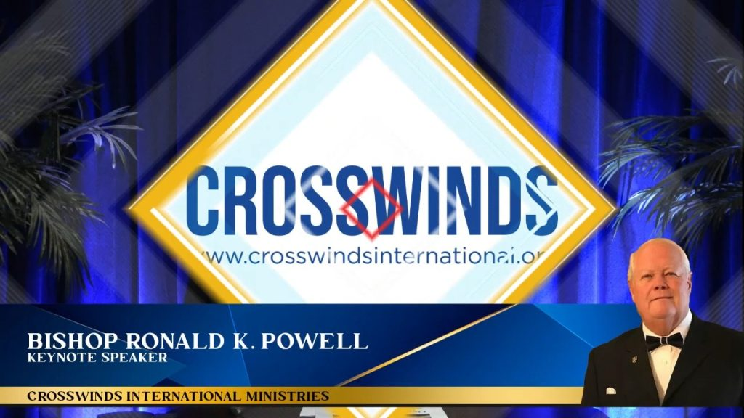

Scripture Reading:
- 1 Corinthians 2:9-14
- 2 Corinthians 5:7

Introduction:
Dear friends, we navigate life daily by what we perceive. We see the world around us, we hear sounds, we touch, taste, and smell. This is how we interact with our physical environment. This is what we call sense knowledge. It’s vital; it tells us when to stop at a red light, how to prepare a meal, or how to comfort a crying child.
But as believers, we are called to live by more than just what our physical senses tell us. We are called to walk by faith, not by sight. And central to that walk is something deeper, something profoundly transformative: Spiritual Revelation. Today, we’re going to explore the critical difference between these two forms of knowledge – sense knowledge and spiritual revelation – and why understanding this distinction is foundational to a vibrant, Spirit-led life.
I. Sense Knowledge: The Realm of the Natural
Let’s begin with what we all understand: sense knowledge.
A. Definition: Sense knowledge is information we gain through our five natural senses: sight, hearing, taste, touch, and smell. It’s how we process the physical world around us. It’s empirical, observable, and often quantifiable.
B. Examples in Daily Life and Scripture:
- When a doctor diagnoses an illness based on symptoms, tests, and observations, that’s sense knowledge.
- When we see the news reports, read a book, or listen to a conversation, that’s sense knowledge being acquired.
- In the Bible, when the disciples saw Jesus crucified on the cross, that was sense knowledge. Their eyes saw Him die. Their ears heard His last breath. This was a brutal, undeniable physical reality.
  - John 20:25 (Thomas’s doubt): Thomas declared, “Unless I see the nail marks in his hands and put my finger where the nails were, and put my hand into his side, I will not believe.” This is the epitome of reliance on sense knowledge. He needed physical proof.
C. Limitations of Sense Knowledge: While essential for navigating the physical world, sense knowledge has profound limitations when it comes to the spiritual realm.
- It can only tell us what is, not necessarily why it is, or what God is doing.
- It cannot perceive God, the spiritual realm, or eternal truths. You can’t see faith, hear hope, or touch love in a physical sense.
- Proverbs 3:5 says, “Trust in the Lord with all your heart and lean not on your own understanding.” Our natural understanding, often based on sense knowledge, is limited and can lead us astray when we try to apply it to spiritual matters.
II. Spiritual Revelation: The Realm of the Divine
Now, let’s turn to the higher form of knowledge: Spiritual Revelation.
A. Definition: Spiritual revelation is knowledge that originates from God, communicated to our spirits by His Holy Spirit. It is not gained through our natural senses or human intellect, but through divine unveiling. It is a direct impartation of truth from the spiritual realm.
B. Examples in Scripture:
- 1 Corinthians 2:9-10 is a foundational text: “However, as it is written: ‘What no eye has seen, what no ear has heard, and what no human mind has conceived’—these things God has revealed to us by his Spirit. The Spirit searches all things, even the deep things of God.”
  - This tells us explicitly that the things of God are beyond natural perception. They require divine revelation.
- Peter’s Confession (Matthew 16:16-17): When Jesus asked His disciples, “Who do you say I am?”, Peter replied, “You are the Messiah, the Son of the living God.” Jesus’ response was crucial: “Blessed are you, Simon son of Jonah, for this was not revealed to you by flesh and blood, but by my Father in heaven.”
  - Peter didn’t figure this out through logic or observation; it was a direct revelation from God.
- Paul’s conversion (Acts 9): Saul, persecuting Christians, had a blinding light and heard a voice. This wasn’t merely a physical event; it was a spiritual revelation that transformed his life and understanding.
C. How Spiritual Revelation Comes:
- Through the Holy Spirit: The Holy Spirit is our divine revealer.
  - 1 Corinthians 2:12-14: “What we have received is not the spirit of the world, but the Spirit who is from God, so that we may understand what God has freely given us. This is what we speak, not in words taught us by human wisdom but in words taught by the Spirit, explaining spiritual realities with Spirit-taught words. The person without the Spirit does not accept the things that come from the Spirit of God but considers them foolishness, as they cannot understand them except through the Spirit.”
- Through God’s Word (Illuminated by the Spirit): The Bible is God’s revealed Word, and the Holy Spirit illuminates it, making its truths alive and understandable to our spirits. We might read a passage 100 times with our natural mind, but then the Spirit opens our eyes to a profound truth we’ve never seen before.
- Through Prayer and Intimacy with God: As we draw near to God, He reveals Himself and His will to us.
III. The Crucial Difference and Its Implications
So, what is the crucial difference, and why does it matter?
A. Source:
- Sense Knowledge: Originates from the natural world, perceived by our physical senses and intellect.
- Spiritual Revelation: Originates from God, communicated to our spirits by His Holy Spirit.
B. Nature:
- Sense Knowledge: Factual, observable, limited to the physical, temporal.
- Spiritual Revelation: Divine truth, spiritual, eternal, often transcends human logic.
C. How It’s Received:
- Sense Knowledge: Through observation, education, experience.
- Spiritual Revelation: Through faith, spiritual sensitivity, and the indwelling Holy Spirit. It’s received by the spirit, not the mind.
D. The Danger of Over-Reliance on Sense Knowledge in Spiritual Matters:
- Walking by sight, not by faith:
  - 2 Corinthians 5:7: “For we live by faith, not by sight.” If we only believe what we can see, feel, or logically understand, we will severely limit God’s work in our lives. We will miss miracles, fail to trust in the unseen, and live below our spiritual inheritance.
  - Imagine Thomas before seeing Jesus – he couldn’t grasp the resurrection through sense knowledge. Many today are like Thomas, waiting for physical proof before believing God.
- Stifling the Holy Spirit: The natural mind often considers spiritual things foolishness, as 1 Corinthians 2:14 states. If our minds are closed off by what we “know” through our senses, we can quench the Spirit’s leading.
E. The Power of Walking in Spiritual Revelation:
- Access to God’s Wisdom: We gain insight into God’s will, purposes, and strategies that are hidden from the natural mind.
- Supernatural Living: We can believe for the impossible, walk in divine healing, overcome overwhelming odds, and experience God’s power in ways that defy natural explanation.
- Deeper Intimacy with God: We come to know God not just about Him, but know Him experientially, through direct communication with His Spirit.
Conclusion:
Brothers and sisters, we are called to live a life that transcends the limitations of the natural. While we wisely use our sense knowledge to navigate this world, our spiritual lives must be founded on spiritual revelation.
It’s about cultivating a sensitivity to the Holy Spirit, allowing Him to illuminate God’s Word, to speak to our hearts, and to guide our steps. When the facts of our circumstances (sense knowledge) scream one thing, spiritual revelation can whisper God’s truth, giving us peace, courage, and a path forward.
Let us not be content to merely understand God with our minds, but let us earnestly pray for spiritual revelation – for eyes to see what no eye has seen, for ears to hear what no ear has heard, and for our spirits to grasp the deep things of God, revealed to us by His Spirit. For it is in this realm of divine revelation that we truly come to know Him, truly walk by faith, and truly experience the fullness of His life within us.
Amen.

